
Instituto Superior de Engenharia do Porto
Departamento de Engenharia Informática

SISTEMAS OPERATIVOS I

Textos de Apoio às Aulas Práticas

MAKE – A Tutorial

extraído do sítio
http://www.eng.hawaii.edu/Tutor/Make/index.html
de Ben Yoshino (ben@wiliki.eng.hawaii.edu)

Novembro de 2002

Lino Oliveira

Sugestões e participações de erros para: lino@dei.isep.ipp.pt

MAKE - A TUTORIAL http://www.eng.hawaii.edu/Tutor/Make/index.html

ÍNDICE

1 Description: the Make command 3

1.1 A simple compilation 3
1.2 Compiling with several files 3
1.3 Separate compilation 4
1.4 Separate compilation steps 4
1.5 Splitting your C program 4

2 Dependencies 5

2.1 Dependency graphs 5
2.2 How dependency works 5
2.3 How does make do it? 6

3 The Makefile 6

3.1 Translating the dependency graph 7
3.2 Listing dependencies 7
3.3 Using the Makefile with make 7

4 Shortcuts for make 8

4.1 Macros in make 8
4.2 Special macros 8
4.3 Predefined rules 9
4.4 Miscellaneous shortcuts 9

5 Advanced features 10

5.1 Special dependencies 10
5.2 Custom suffixes and rules 10

Make - bibliography 10

Author: Ben Yoshino (ben@wiliki.eng.hawaii.edu)

Copyright © 2001 University of Hawaii, College of Engineering, Computer Facility
All rights reserved.

DESCRIPTION: THE MAKE COMMAND

The make command allows you to manage large programs or groups of programs. As you begin to write larger programs, you will notice that re-compiling larger programs takes much longer than re-compiling short programs. Moreover, you notice that you usually only work on a small section of the program (such as a single function that you are debugging), and much of the rest of the program remains unchanged.

The make program aids you in developing your large programs by keeping track of which portions of the entire program have been changed, compiling only those parts of the program which have changed since the last compile.

A SIMPLE COMPILATION
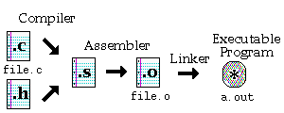
Compiling a small C program requires at least a single .c file, with .h files as appropriate. Although the command to perform this task is simply cc file.c, there are 3 steps to obtain the final executable program, as shown:
- Compiler stage: All C language code in the .c file is converted into a lower-level language called Assembly language; making .s files.
- Assembler stage: The assembly language code made by the previous stage is then converted into object code which are fragments of code which the computer understands directly. An object code file ends with .o.
- Linker stage: The final stage in compiling a program involves linking the object code to code libraries which contain certain "built-in" functions, such as printf. This stage produces an executable program, which is named a.out by default.

COMPILING WITH SEVERAL FILES
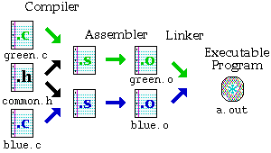
When your program becomes very large, it makes sense to divide your source code into separate easily-manageable .c files. The figure above demonstrates the compiling of a program made up of two .c files and a single common.h file. The command is as follows:
cc green.c blue.c
where both .c files are given to the compiler. Note that the first two steps taken in compiling the files are identical to the previous procedure for a single .c file, but the last step has an interesting twist: The two .o files are linked together at the Linker stage to create one executable program, a.out.

SEPARATE COMPILATION
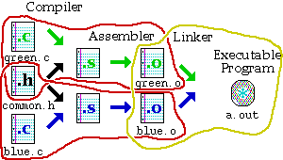
The steps taken in creating the executable program can be divided up in to two compiler/assembler steps circled in red, and one final linker step circled in yellow. The two .o files may be created separately, but both are required at the last step to create the executable program.

You can use the -c option with cc to create the corresponding object (.o) file from a .c file. For example, typing the command: cc –c green.c will not produce an a.out file, but the compiler will stop after the assembler stage, leaving you with a green.o file.

SEPARATE COMPILATION STEPS
The three different tasks required to produce the executable program are as follows:

- Compile green.o: cc -c green.c
- Compile blue.o: cc -c blue.c
- Link the parts together: cc green.o blue.o

For example, it is important to note that in order to create the file, green.o, the two files, green.c and the header file common.h are required. Similarly, in order to create the executable program, a.out, the object files green.o and blue.o are required.

SPLITTING YOUR C PROGRAM

When you separate your C program into many files, keep these points in mind:
- Be sure no two files have functions with the same name in it. The compiler will get confused.
- Similarly, if you use global variables in your program, be sure no two files define the same global variables.
- If you use global variables, be sure only one of the files defines them, and declare them in your .h as follows: extern int globalvar;
- To use functions from another file, make a .h file with the function prototypes, and use #include to include those .h files within your .c files.
- At least one of the files must have a main() function.
Note: When you define a variable, it looks like this: int globalvar;. When you declare a variable, it looks like this: extern int globalvar;. The main difference is that a variable definition creates the variable, while a declaration indicates that the variable is defined elsewhere. A definition implies a declaration.

DEPENDENCIES

The principle by which make operates was described to you in the last section. It creates programs according to the file dependencies. For example, we now know that in order to create an object file, program.o, we require at least the file program.c. (There may be other dependencies, such as a .h file.)

This section involves drawing what are called "dependency graphs", which are very similar to the diagrams given in the previous section. As you become proficient using make, you probably will not need to draw these diagrams, but it is important to get a feel for what you are doing.

DEPENDENCY GRAPHS
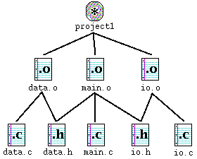
This graph shown in the figure is a program which is made up of 5 source files, called data.c, data.h, io.c, io.h, and main.c. At the top is the final result, a program called project1. The lines which radiate downwards from a file are the other files which it depends on. For example, to create main.o, the three files data.h, io.h, and main.c are needed.

HOW DEPENDENCY WORKS

Suppose that you have gone through the process of compiling the program, and while you are testing the program, you realize that one function in io.c has a bug in it. You edit io.c to fix the bug.

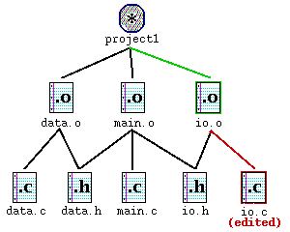
The figure above shows io.c outlined in red. By going up the graph, you notice that io.o needs to be updated because io.c has changed. Similarly, because io.o has changed, project1 needs to be updated as well.

HOW DOES MAKE DO IT?
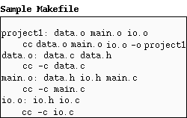
The make program gets its dependency "graph" from a text file called makefile or Makefile which resides in the same directory as the source files. Make checks the modification times of the files, and whenever a file becomes "newer" than something that depends on it, (in other words, modified) it runs the compiler accordingly.

For example, the previous page explained io.c was changed. If you edit io.c, it becomes "newer" than io.o, meaning that make must run cc –c io.c to create a new io.o, then run cc data.o main.o io.o -o project1 for project1.

THE MAKEFILE

The previous section described dependencies between files. This section describes the make program in more detail by describing the file it uses, called makefile or Makefile. This file determines the relationships between the source, object and executable files.

TRANSLATING THE DEPENDENCY GRAPH
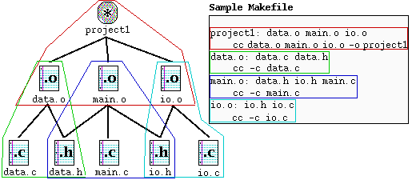
Each dependency shown in the graph is circled with a corresponding color in the Makefile, and each uses the following format:

target : source file(s)
command (must be preceded by a tab)

A target given in the Makefile is a file which will be created or updated when any of its source files are modified. The command(s) given in the subsequent line(s) (which must be preceded by a tab character) are executed in order to create the target file.

LISTING DEPENDENCIES

project1: data.o main.o io.o
cc data.o main.o io.o -o project1
data.o: data.c data.h
cc -c data.c
main.o: data.h io.h main.c
cc -c main.c
io.o: io.h io.c
cc -c io.c

Note that in the Makefile shown above, the .h files are listed, but there are no references in their corresponding commands. This is because the .h files are referred within the corresponding .c files through the #include "file.h". If you do not explicitly include these in your Makefile, your program will not be updated if you make a change to your header (.h) files.

Note: Comments can be placed in a Makefile by placing a pound sign (#) in front of it.

USING THE MAKEFILE WITH MAKE

Once you have created your Makefile and your corresponding source files, you are ready to use make. If you have named your Makefile either Makefile or makefile, make will recognize it. If you do not wish to call your Makefile one of these names, you can use make –f mymakefile. The order in which dependencies are listed is important. If you simply type make and then return, make will attempt to create or update the first dependency listed.

You can also specify one of the other targets listed in the Makefile, and only that target (and its corresponding source files) would be made. For example, if we typed make, the output of make would look as follows:

% make
cc -c data.c
cc -c main.c
cc -c io.c
cc data.o main.o io.o -o project1
%

When making its targets, make first checks the source files and attempts to create or update the source files. That is why data.o, main.o and io.o were created before attempting to create the target: project1.

SHORTCUTS FOR MAKE

The make program has many other features which have not been discussed in previous sections. Most important of these features is the macro feature. Macros in make work similarly to macros used in C programming. Make also has its own pre-defined rules which you can take advantage of to make your Makefile smaller.

MACROS IN MAKE

The make program allows you to use macros, which are similar to variables, to store names of files. The format is as follows:
OBJECTS = data.o io.o main.o
Whenever you want to have make expand these macros out when it runs, type the following corresponding string $(OBJECTS).

Here is our sample Makefile again, using a macro.

OBJECTS = data.o main.o io.o
project1: $(OBJECTS)
cc $(OBJECTS) -o project1
data.o: data.c data.h
cc -c data.c
main.o: data.h io.h main.c
cc -c main.c
io.o: io.h io.c
cc -c io.c

You can also specify a macro's value when running make, as follows:
make 'OBJECTS=data.o newio.o main.o' project1
This overrides the value of OBJECTS in THE Makefile

SPECIAL MACROS

In addition to those macros which you can create yourself, there are a few macros which are used internally by the make program. Here are some of those, listed below:

CC Contains the current C compiler. Defaults to cc.
CFLAGS Special options which are added to the built-in C rule. (See next page.)
$@ Full name of the current target.
$? A list of files for current dependency which are out-of-date.
$< The source file of the current (single) dependency.

You can also manipulate the way these macros are evaluated, as follows, assuming that OBJS = data.o io.o main.o, using $(OBJS:.o=.c) within the Makefile substitutes .o at the end with .c, giving you the following result: data.c io.c main.c

PREDEFINED RULES

By itself, make knows already that in order to create a .o file, it must use cc -c on the corresponding .c file. These rules are built into make, and you can take advantage of this to shorten your Makefile. If you just indicate just the .h files in the dependency line of the Makefile that the current target is dependent on, make will know that the corresponding .c file is already required. You don't even need to include the command for the compiler.

This reduces our Makefile further, as shown:
OBJECTS = data.o main.o io.o
project1: $(OBJECTS)
cc $(OBJECTS) -o project1
data.o: data.h
main.o: data.h io.h
io.o: io.h

One thing to consider, however, is that when you are compiling programs on Wiliki, you may wish to add a CFLAGS macro at the top of your Makefile to enable the compiler to use ANSI standard C compilation.
The macro looks like this:
CFLAGS=-Aa -D_HPUX_SOURCE
This will allow make to use ANSI C with the predefined rules.

MISCELLANEOUS SHORTCUTS

Although the examples we have shown do not explicitly say so, you can put more than one file in the target section of the dependency rules. If a file appears as a target more than once in a dependency, all of its source files are included as sources for that target.

Here is our sample Makefile again:
CFLAGS = -Aa -D_HPUX_SOURCE
OBJECTS = data.o main.o io.o
project1: $(OBJECTS)
cc $(OBJECTS) -o project1
data.o main.o: data.h
io.o main.o: io.h

This Makefile shows main.o appearing in two places. Make knows by looking at all the dependencies that main.o depends on both data.h and io.h.

ADVANCED FEATURES

Make has some advanced features which we will discuss very briefly in this section. This includes specialized dependency rules, as well as writing Makefiles to work with your own suffixes, and writing new "built-in" rules.

SPECIAL DEPENDENCIES

Usually, make uses the same command to create or update a target, regardless of which file changes. Some other files, such as libraries allow users to replace a portion of its code. For this kind of different behavior, make allows a special form of the dependency, where the action specified can differ, depending on which file has changed. Here is an example for this rule:

target :: source1
command1
target :: source2
command2

As we have described, if source1 changes, target is created or updated using command1; command2 is used if source2 is modified instead.

CUSTOM SUFFIXES AND RULES

Make uses a special target, named .SUFFIXES to allow you to define your own suffixes. For example, the dependency line:
.SUFFIXES: .foo .bar
tells make that you will be using these special suffixes to make your own rules.

Similar to how make already knows how to make a .o file from a .c file, you can define rules in the following manner:

.foo.bar:
tr '[A-Z][a-z]' '[N-Z][A-M][n-z][a-m]' < $< > $@
.c.o:
$(CC) $(CFLAGS) -c $<

The first rule allows you to create a .bar file from a .foo file. (Don't worry about what it does, it basically scrambles the file.) The second rule is the default rule used by make to create a .o file from a .c file.

MAKE - BIBLIOGRAPHY
- Stuart Feldman. Make - A Program for Maintaining Computer Programs. Software - Practice and Experience, 9:255-265, 1979.
- Hewlett-Packard. On-line manual pages for make
(http://www.eng.hawaii.edu/cgi-bin/man-gateway?make). 1992.

